MASAMBE
Seats 60

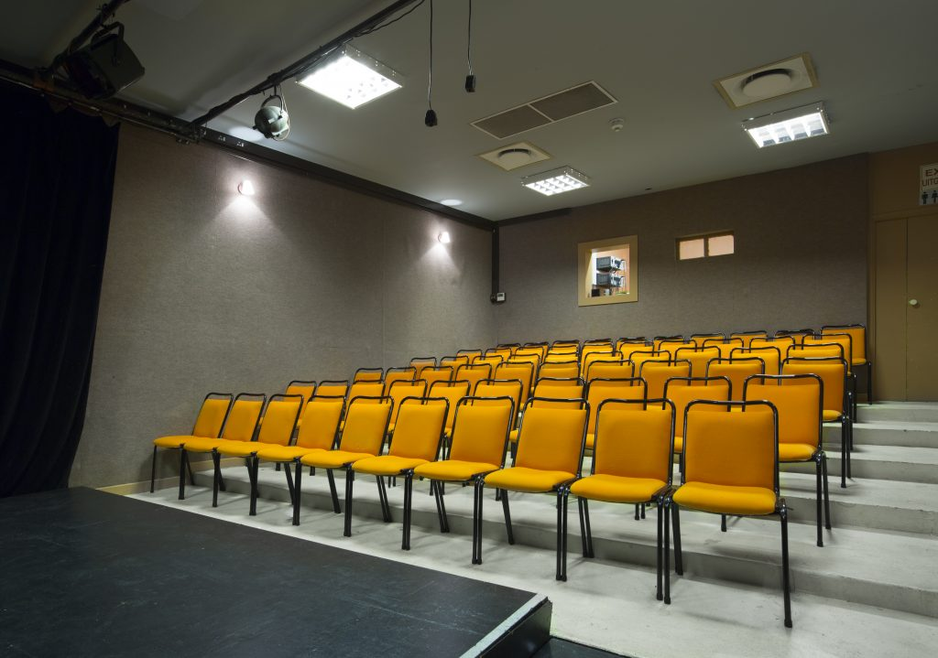

Basic size of the stage
As per plan

LX
CONTROL
Control is a grandMA Pico

DIMMERS
Dimmers can be soft patched to you channel allocation. If you choose not to specify channels, dimmer numbers will be used.
12 | STRAND 2kW dimmers

LX EQUIPMENT
18 x patt 123

SD
CONTROL
12 channel SOUNDCRAFT analogue desk
2x 8inch JBL speakers

CURTAINS
1x set black velvet surround

